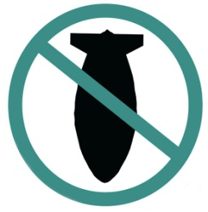

STOP THE WAR COALITION
stopwar.org.uk @STWuk fb.com/stopthewarcoalition
Free Palestine - Stop Arming Israel
Israel continues to persecute civilians in the besieged territory of Gaza and evict Palestinian families from their homes in East Jerusalem. Illegal settlements in the occupied territories have accelerated with hundreds more families expelled from their homes. With over 250 Palestinians killed in the recent Israeli attacks it is imperative that Britain immediately stops selling arms to Israel and calls for an end to the evictions.

Name | Postcode | Email | Phone No.
By signing this petition you are agreeing to Stop the War Coalition contacting you by email as part of our campaigning. StWC respects data protection and keeps all your data secure. We do not use your data for any other purpose. Return to: Stop the War Coalition, 86 Durham Road, London, N7 7DT. Tel: 020 7561 4830
By signing this petition you are agreeing to Stop the War Coalition contacting you by email as part of our campaigning. StWC respects data protection and keeps your data secure. We do not sue your data for any other purpose.
Return to: Stop the War Coalition, 86 Durham Road, London N7 7DT. Tel: 020 7561 4830

